SALES QUOTATION – RR.24-25.0118(R10)

Reliance Industries Ltd. Date – 14/10/2024
Project – Vrindavan, Mumbai
Product – Automatic Lifting, Sliding and Stacking Platform of Swimming Pool (Automatic Swimming Pool Deck cover)

Kind Attn: Mr. Manoj Mishra ji

Thank you for your opportunity and trust shown on “NIHVA” your preferred partner for innovative solutions. This has reference to your above-mentioned requirement, please find below our Solutions.
Operational Technique
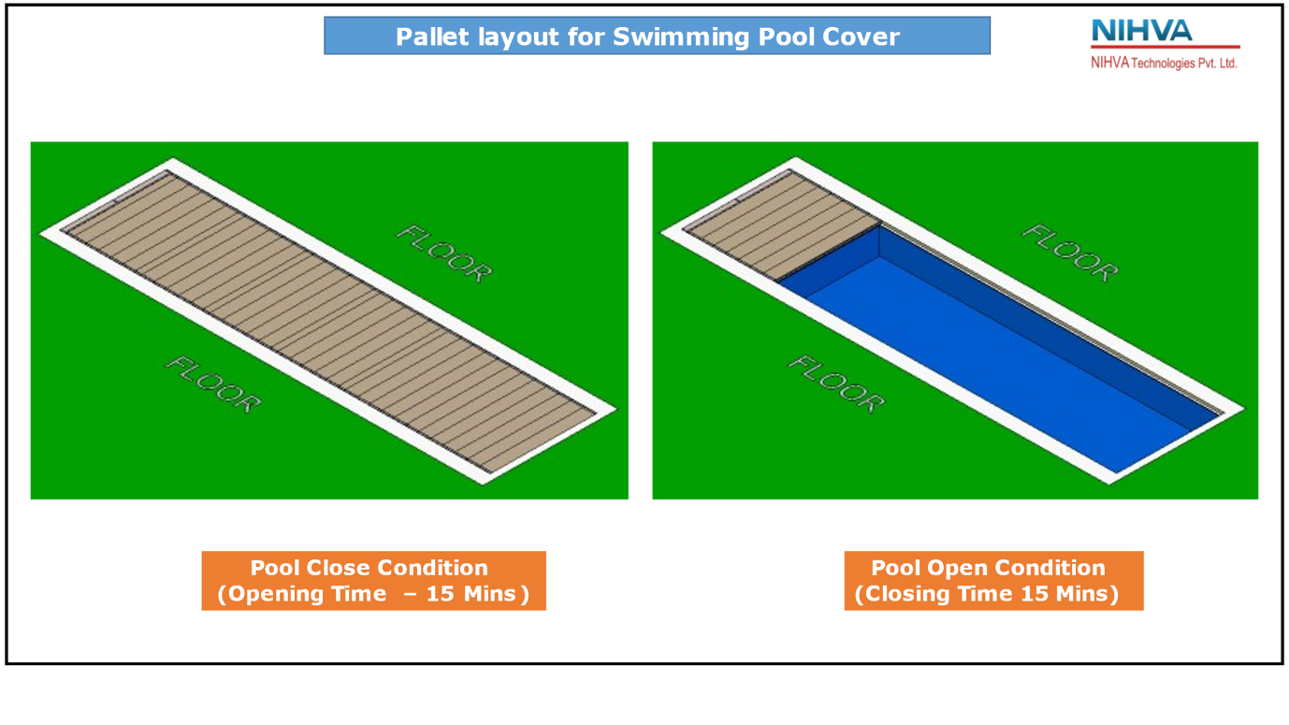
The whole framework, which is divided into pallets is made of SS 316L/SS 304/GI grade. These pallets are going to slide with the help of induction motor and gearbox towards the pit. One by one they will get stacked and pit assembly will move vertically down each time pallet enters. The system does not depend on hydraulic, pneumatic etc. It only works on electrical system with all logic connected through control panel.

Commercial Details –

OPTIONS | PRODUCT | MATERIAL | QTY | SUPPLY & INSTALLATION | AMOUNT
1 | Swimming Pool Deck Cover. | SS316L | 1 | ₹ 2,69,00,000 | ₹ 2,69,00,000
2 | Swimming Pool Deck Cover. | SS304 | 1 | ₹ 2,35,00,000 | ₹ 2,35,00,000
3 | Swimming Pool Deck Cover. | GI | 1 | ₹ 1,86,00,000 | ₹ 1,86,00,000

Please note we recommend only SS316L and SS306 Material.
General Terms & Conditions-
  - NIHVA is going to use external structural consultant for structural pallet stability.

  - NIHVA will conduct trial of MS prototype on 2 pallet system.

  - NIHVA will conduct load testing on the prototype pit system as per the actual load on site.

  - Make and Model of electrical components would be finalized with the consent of client’s site team from the suggestion provide by NIHVA team.

  - Multiple site visit will be going to carried out at different stages of project by NIHVA.

  - FAT shall be carried out before dispatch.

  - Continuous uninterrupted access to installation section or as agreed separately.

  - Provision of 230 Volt power supply (by others) for hand tools.

  - A dry and secure area, not in direct sunlight, is to be provided for storage of the product components.

  - Access to site between 7 am to 12 pm six days per week. If this is not possible, the installation programme may require amending.

  - Any storage costs for materials due to delays outside of NIHVA, will be in Client Scope.

  - Unloading of material and internal movement of material on site to the installation area is under NIHVA scope subject to providing of material lift by client.

  - The project time indicated does not take into account adverse weather conditions, pandemic situation, local Govt restrictions that may prevent safe and efficient working practices. We reserve the right to extend the period accordingly.

  - Any passes required for the project, are the responsibility of the Customer and Contractor and must be available, before commencement of the installation. Any delays caused by the non-availability of passes, will be charged accordingly.

  - The functionality and performance of whole system that is engagement of pallet and pool, engagement of pallet and pit, surface level of pool, alignment of surface civil work, plumb level is crucial hence RIL team to should understand and work together for successfully commissioning of the product.

Sr. No | Remark
1 | Secured and fully covered Store area to keep the material | In Client Scope
2 | Scaffolding/Hydra/Crane/Forklift etc - Required for Installation at Site | In NIHVA Scope
3 | Electrical Supply on the site single phase/three phase points at different places. | In Client Scope
4 | Any civil / masonry/structural work required | In Client Scope
5 | All structure support required | In NIHVA Scope
6 | In Case of any changes in the layout as per site requirements after the shipment of material, the additional quantities and the wastage. | In Client Scope
7 | Conduits, Cables required | In Client Scope

Terms & Conditions-

Price: Ex Works Pune

Delivery: Approximately 15-18 weeks from having received official order confirmation + advance payment + signed & stamp drawing approval

Supply/Installation Payment:
30% Advance along with confirmed Purchase order on Supply price
30% after testing of prototype sliding mechanism (partially)
25% before SS procurement
10% before dispatch and FAT
5% after completion of installation
Advance BG will be applicable only if min. 60% advance approved till first prototype inspection and testing else for 25% no ABG

Validity: Validity of Offer is 7 days from the date of quotation.
(Due to increase in price of SS 316L day by day)

Warranty: from date of supply -
2 Years for manufacturing defect on the structural system
1 Year on Mechanical drive system and for all electrical components

AMC: To be discuss

Design Clause:
NIHVA shall be deemed the authors of their respective concept and drawings with reserved rights, including copyrights. It shall not be used by the owner for future additions or alterations to this Project or for another project or should not copied at any other future project or should not transfer or copied by anyone.

Compensation Clause:
Please note that in the event the buyer cancels an order, after the order is confirmed to us, it is binding to the buyer to pay NIHVA a compensation of 25% of order value.

Please feel free to Contact us for any further Clarification Information in this Concern.

With Best Regards,
Pranav Marne
+91-77588 20333

